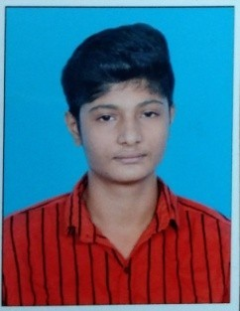 **RESUME**

**GOHUL R**

3/78B Marakudi Street

Kanyakumari Dist,

Pincode:629702 Ph.No:8754737319

Email:gohulgohul70@gmail.com

**CAREER OBJECTIVE**

To peruse in an organization with performance oriented environment for achievement of personal advancement. Being ambitious & hard working.

**EDUCATIONAL QUALIFICATION**

|  |  |  |  |  |
| --- | --- | --- | --- | --- |
| **Course** | **Institution** | **Board/University** | **Year Of Passing** | **Mark**  **Percentage** |
| B.Sc | S.T. Hindu college, Nagercoil. | M.S University | 2024 | 8.41% |
| HSC | Vivekananda Kendra  Vidyalaya Matric Higher Secondary School Kanyakumari. | Tamil Nadu State Board | 2021 | 84.6% |
| SSLC | Vivekananda Kendra  Vidyalaya Matric Higher Secondary School Kanyakumari. | Tamil Nadu State Board | 2019 | 76% |

**TECHNICAL SKILLS**

* PYTHON
* MS EXCEL, MS WORD

**PERSONAL SKILLS**

* Communication
* Motivation
* Team Work

**LANGUAGES:**

* Tamil
* English

**HOBBIES:**

* Reading Books
* Listening Music

**PERSONAL DETAILS**

|  |  |  |
| --- | --- | --- |
| Name | : | GOHUL R |
| Father Name | : | R.RAVICHANDRAN |
| Date of Birth | : | 23/11/2003 |
| Age | : | 19 |
| Sex | : | Male |
| Marital Status | : | Single |
| Nationality | : | Indian |
| Languages Known: | | English & Tamil |

**DECLARATION**

I hereby declare that the above mentioned information is true and correct to my knowledge.

|  |  |
| --- | --- |
| **Date:** 19.10.2023 | Yours faithfully, |
| **Place:** Kanyakumari. | (**GOHUL R**) |